Slide 1 | 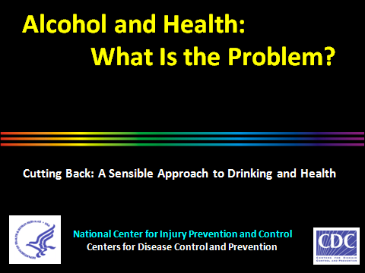
Slide 2 | 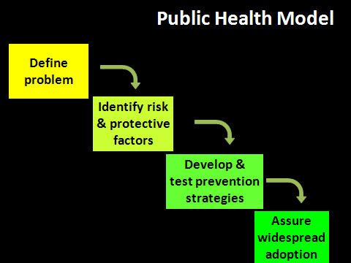 | Addressing public health problems typically involves these four steps. However, if the problem is not defined accurately, we may not identify the best solution.  This short presentation will show how our understanding of the “alcohol problem” has developed over the last several decades.
Slide 3 | 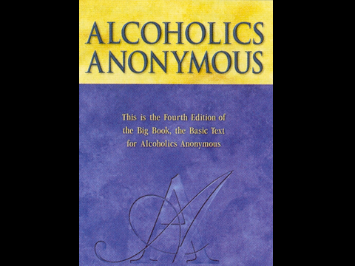 | Beginning in 1935 Alcoholics Anonymous (AA) popularized the concept of alcoholism and motivated research that led to it being considered a disease. The underlying concept was that certain individuals are uniquely vulnerable to alcohol, and AA maintains that they should remain abstinent to avoid further problems.  Since then, scientific knowledge has expanded, and two fundamental realities have become clear: 1) Alcohol is toxic to anyone who consumes too much. 2) Most people who consume too much are not alcoholics.
Slide 4 |  | In the U.S. most people use the AA concept of alcoholism to understand the “alcohol problem.” This perspective divides the population into two groups, like this stoplight. Red represents the group that’s vulnerable and likely to become alcoholic. And green represents the rest of the population that is, presumably, not vulnerable.  In other words, if you’re an alcoholic, you shouldn’t drink at all. If you’re not, you need not be concerned with how much you drink because you are not an alcoholic.  This ignores the fact that intoxication is a major risk factor for injuries and clearly not restricted to alcoholics
Slide 5 | 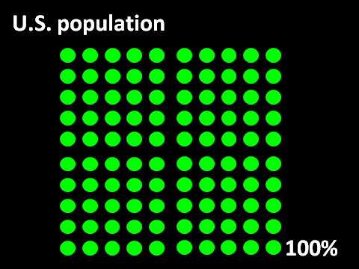 | A new conceptual view of the “alcohol problem” began in the 1960s when the first surveys of drinking in the U.S. population began. The whole population was sampled, not just alcoholics. The surveys asked how much, how often, and what kinds of beverages people drank. They also asked about the whole range of negative consequences people experienced as a result of their drinking.  In this slide, each dot represents 1% of the non-institutionalized, civilian population—the group sampled.
Slide 6 | 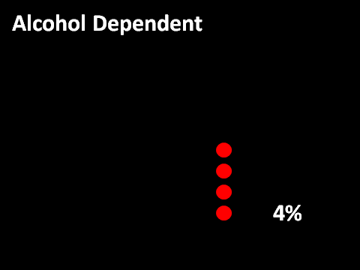 | Less than four percent of the population could be diagnosed as alcohol dependent—in common parlance, alcoholic.  This is a relatively small percentage of the whole population. However, in a big country with more than 300 million people, it’s a large group.  Grant BF, Dawson DA, Stinson FS, Chou SP, Dufour MC, Pickering RP. The 12-month prevalence and trends in DSM-IV alcohol abuse and dependence: United States, 1991–1992 and 2001–2002. Drug Alcohol Depend. 2004;74:223–234.
Slide 7 | 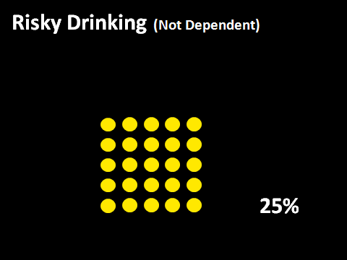 | 25% of the population is in the risky drinking (not dependent) category. They drink too much, but they are not dependent on alcohol.  Some people in this group are drinking too much, but have not yet experienced harm. Studies show that their risk for harm increases if they continue to drink too much.  Other people in this group have already experienced harm or dependence symptoms, but not to the degree that would support a diagnosis of dependence.  Whether or not they progress to dependence, people in this group are at elevated risk for harm—social, legal, physical, and medical.
Slide 8 | 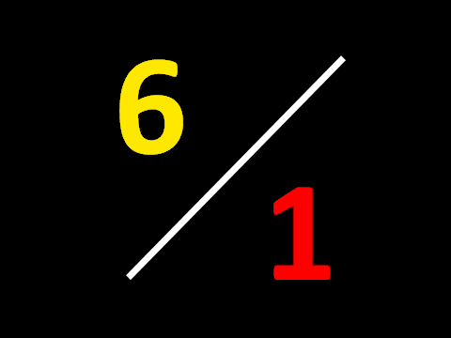 | Thus, for every 1 person addicted to alcohol in the U.S.—the red number on this slide, there are 6 other people who drink too much.  This six-to-one ratio means that even if we could cure every alcoholic in the country, we wouldn’t have addressed most of the alcohol-related harm our country experiences.  Most people understand at some level that you don’t have to be an alcoholic to get hurt from your drinking or to hurt others. Nonetheless, the concept of alcoholism has dominated our thinking about alcohol.
Slide 9 |  | Our common traffic light is a more accurate representation of the new conceptual model of the “alcohol problem”. The red and the green categories remain the same.  The yellow represents those non-addicted individuals who drink too much—a very large group.
Slide 10 | 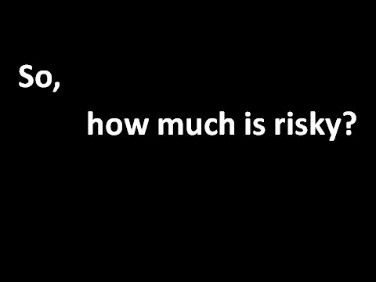 | So the problem we must address to create a healthier society is not only alcoholism, it is also the much more common behavior of risky drinking.  But How much drinking qualifies as too much?  “If alcohol is consumed, it should be consumed in moderation—up to one drink per day for women and two drinks per day for men—and only by adults of legal drinking age.”  U.S. Department of Agriculture and U.S. Department of Health and Human Services. Dietary Guidelines for Americans, 2010. 7th Edition, Washington, DC: U.S. Government Printing Office, December 2010.
Slide 11 | 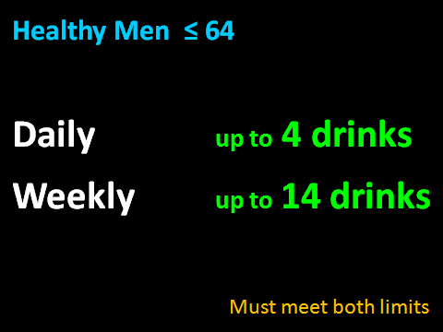 | The National Institute on Alcohol Abuse and Alcoholism recommends maximum drinking limits. Consumption over these limits is risky in that it results in a wide variety of negative consequences.  The limits shown here are for healthy men age 64 and under. Daily limits seek to prevent intoxication. Weekly limits are designed to reduce the many medical consequences associated with regular excessive consumption. Men should drink no more than 4 drinks per day AND no more than 14 drinks per week.  http://pubs.niaaa.nih.gov/publications/Practitioner/CliniciansGuide2005/clinicians_guide5_help_p.htm
Slide 12 | 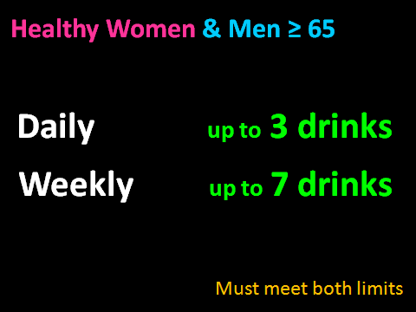 | The limits for women and older men are lower because they digest alcohol differently than younger men.  And they, too, must meet both limits to avoid risky drinking and its associated harm.  http://pubs.niaaa.nih.gov/publications/Practitioner/CliniciansGuide2005/clinicians_guide5_help_p.htm
Slide 13 | 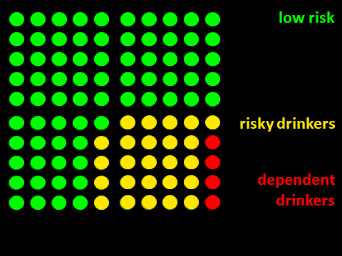 | So 71% of the population either does not drink or drinks within the NIAAA guidelines.*  Risky drinkers, the 25% in yellow, drink over those guidelines but are not dependent, so they do not require the same medical response as dependent drinkers, depicted in red.  * Dawson DA, Grant BF, Stinson FS et al. Toward the Attainment of Low-Risk Drinking Goals: A 10-Year Progress Report. Alcohol Clin Exp Res 2004;28:1371-1378.
Slide 14 | 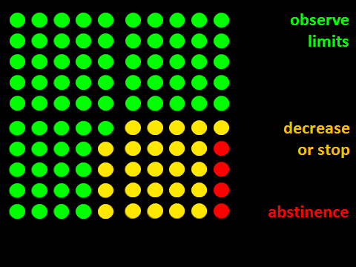 | Low-risk individuals (green) are not risky drinkers. However, you should educate them about appropriate drinking limits. A brochure may suffice.  Dependent drinkers (red) should receive specialized alcohol treatment.  It is inappropriate to refer risky drinkers (yellow) to specialized alcohol treatment. They should receive a brief intervention.
Slide 15 | 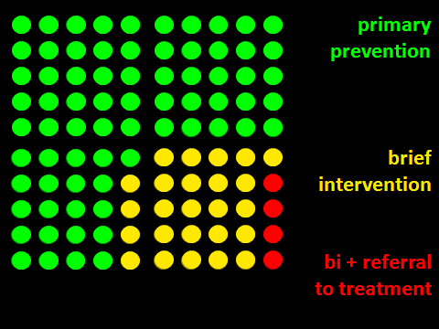 | The new definition of the “alcohol problem” also requires different goals for each of the risk categories.  The goal for risky drinkers (yellow) is to decrease how much they drink and/or to abstain.  The goal for the low risk group (green)—continue to drink less than the recommended limits. We want people to remain in this category and not join one of the other two categories over time.
Slide 16 | 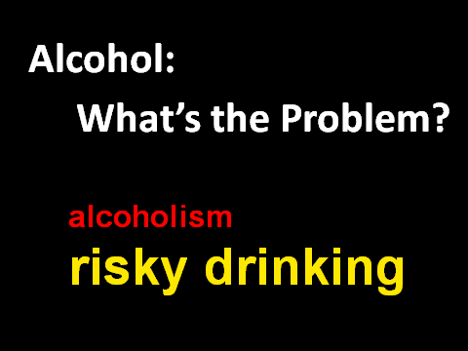 | Redefining the problem: “The problem is not only alcoholism. It is risky drinking, in addition to alcoholism. No one becomes an alcoholic without first engaging in risky drinking, sometimes for a prolonged period of time.  Further, many who are risky drinkers but not alcoholics are harmed irreparably by drinking too much. Many risky drinkers also die or injure and kill other people before they live long enough to beome alcoholic.
Slide 17 | 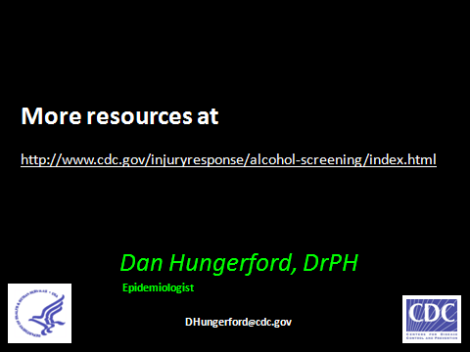 | Screening and Brief Intervention can help identify all risky drinkers, including alcoholics, and help clinicians refer to appropriate treatment or care.  The CDC, in partnership with NHTSA and the ACS-COT, have developed a series of tools called Cutting Back. It includes an online training with videos and an implementation guide to help practitioners get trained and implement SBI in trauma settings.  http://www.cdc.gov/injuryresponse/alcohol-screening/index.html

